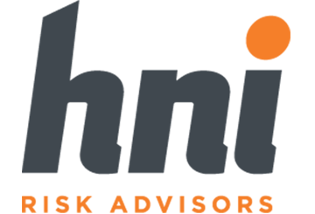
Provided by HNI

Table of Contents
Introduction 3
What Is the Commercial Driver’s License Drug and Alcohol Clearinghouse? 3
Overview and Applicability of the Clearinghouse 4
Registering for the Clearinghouse 5
Information Contained Within the Clearinghouse Database 5
How the Clearinghouse Will Be Used 7
Compliance Considerations: Employers 9
Conducting a Query 9
Reporting Requirements 10
Penalties 14
Driver Notification and Consent 14
Updating Programs and Policies on the Misuse of Alcohol and Controlled Substances 14
Controlled Substance and Alcohol Testing Programs 15
Written Policies Related to Controlled Substance and Alcohol Misuse 17
Compliance Considerations: Drivers 19
Types of Drivers Affected by the Clearinghouse 19
Data Privacy and Providing Consent 20
Continued Safety 21
Clearinghouse FAQs 23

This guide is not intended to be exhaustive nor should any discussion or opinions be construed as legal advice. Readers should contact legal counsel for legal advice. © 2019 Zywave, Inc. All rights reserved.

Introduction
The Federal Motor Carrier Safety Administration (FMCSA) and the businesses it governs have a responsibility to ensure the safety of those on the road. Above all, in order to prevent crashes and fatalities on public highways, the FMCSA expects motor carriers to hire qualified drivers who respect applicable commercial motor vehicle (CMV) legislation and proper operating procedures.
As part of this commitment to safety, the FMCSA focuses heavily on the misuse of drugs and alcohol—a major contributor to highway crashes and deaths. According to the most recent data from the FMCSA, positive drug tests for drivers of large trucks involved in fatal crashes increased 48% from 2015 to 2017.
To help address concerns related to impaired driving and protect both commercial driver’s license (CDL) holders and the individuals with whom they share the road, the FMCSA established the CDL Drug and Alcohol Clearinghouse.

What Is the Commercial Driver’s License Drug and Alcohol Clearinghouse?
On Dec. 5, 2016, the FMCSA issued a final rule that established a National Drug and Alcohol Clearinghouse. The Clearinghouse is a secure online database that gives employers, the FMCSA, state driver licensing agencies and law enforcement personnel real-time access to important information about a CDL holder’s drug and alcohol program violations.
Effective Jan. 6, 2020, motor carriers must use the Clearinghouse to check a current employee’s status at least once per year, review violations and ensure drivers are eligible to operate a CMV.* While the Clearinghouse does not alter existing drug and alcohol testing requirements, it will likely have a significant impact on internal processes and the way motor carriers onboard new drivers. In addition, there are very specific steps motor carriers need to follow in order to comply with the final rule, meet reporting requirements, avoid violating privacy laws and protect themselves from substantial penalties.
This guide is designed to help motor carriers of all sizes better understand their Clearinghouse compliance burden. It includes specifics about the Clearinghouse process and ways employers can meet the legal standards set by the FMCSA.

*Note: The FMCSA has extended the compliance date for state licensing authorities. With the extension, states must query the Clearinghouse before completing certain commercial driver's license transactions by Jan. 6 2023 (original compliance deadline was Jan. 6, 2020). This proposed delay will give the FMCSA more time to clarify rules related to the way state driver licensing agencies access and use driver-specific information found in the Clearinghouse. The original Jan. 6, 2020 compliance date will remain in place for all other requirements spelled out in the Clearinghouse rule.

Overview and Applicability of the Clearinghouse
Again, the Clearinghouse is an online database established by the FMCSA. It gives key stakeholders—motor carriers, CDL drivers, medical review officers, substance abuse professionals (SAPs), consortium/third-party administrators (sometimes referred to as service agents) and state driver licensing agencies—the ability to search a CDL holder’s drug and alcohol violations. This, in turn, helps carriers and other parties identify drivers who are prohibited from operating CMVs due to drug and alcohol violations and refusals to test.
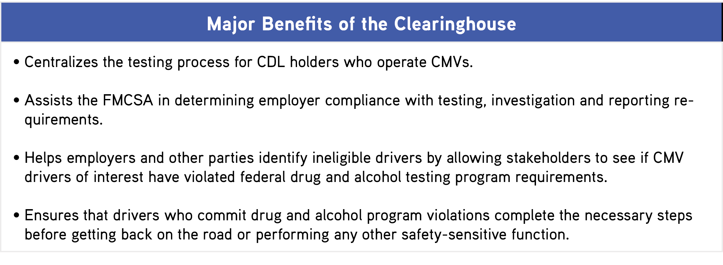

Under the final rule, motor carriers and other employers of CMV drivers must use the Clearinghouse to ensure that current and prospective employees do not have any unresolved drug and alcohol violations that affect their driving eligibility. Employers will also be required to report information about positive drug test results, alcohol test results greater than a 0.04 blood alcohol content, refusals to test and other non-test violations of FMCSA’s drug and alcohol regulations.
Stakeholders must register in order to access the Clearinghouse database. The timeline below outlines other key dates:
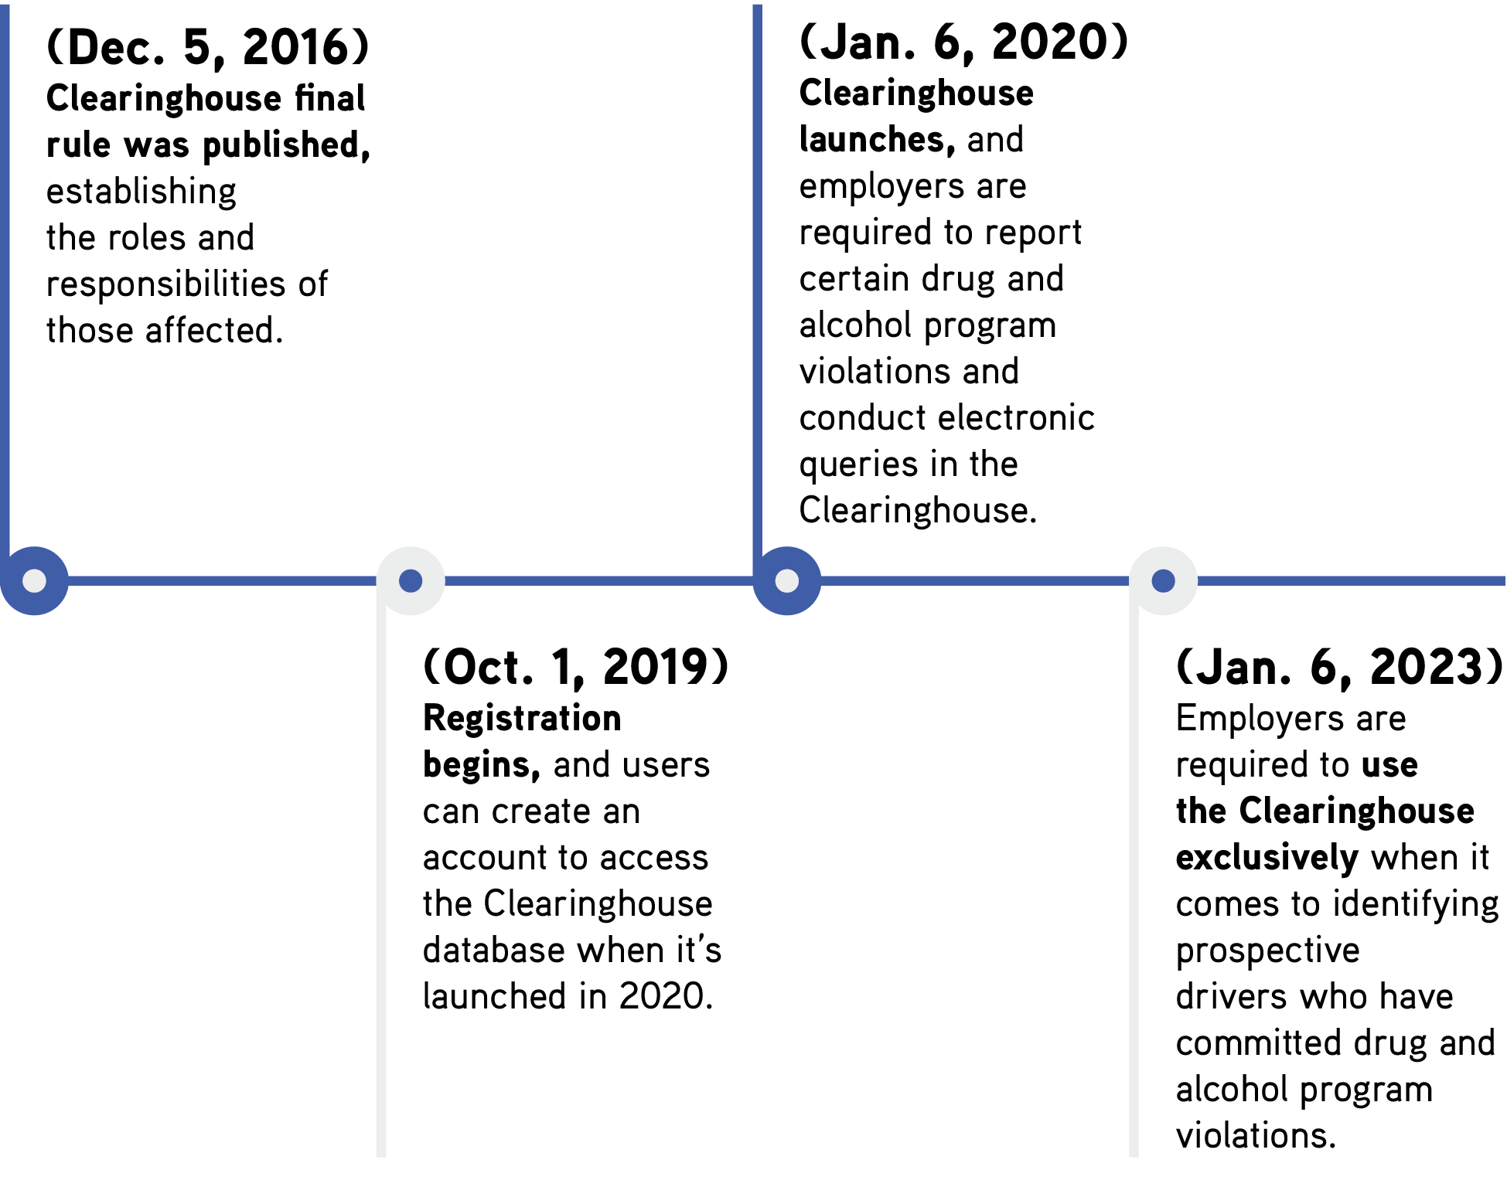

Registering for the Clearinghouse
Again, employers, drivers, medical review officers, SAPs and service agents must register in order to access the Clearinghouse information. To register, stakeholders will need a login.gov account.
Use the applicable links below to complete the registration process:
- If you have a login.gov account and want to begin the registration process, click here.
- If you don’t have a login.gov account and wish to create one, click here.

Information Contained Within the Clearinghouse Database
The Clearinghouse contains information about those covered by the FMCSA’s drug and alcohol program. In general, the program applies to all drivers who operate CMVs subject to the CDL requirements and perform safety-sensitive functions. As such, the Clearinghouse affects the majority of full-time, part-time, intermittent, backup and international drivers. It also contains information on drivers with commercial learner’s permits (CLPs).
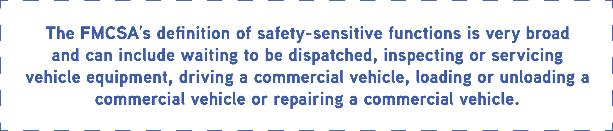

Information contained in the Clearinghouse will relate to violations of 49 CFR Part 382, Subpart B that occur on or after the implementation date of Jan. 6, 2020. These include, but are not limited to, the following types of infractions:
- A driver reports for or remains on duty for a safety-sensitive function with an alcohol concentration of 0.04 or greater or while using any drug specified in 49 CFR part 40.
- A driver consumes alcohol while performing (or within four hours of performing) a safety-sensitive function.
- A driver consumes alcohol within eight hours of an accident or post-accident test.
- A driver tests positive for a controlled substance.
- A driver refuses to submit to a required alcohol or drug test.
In addition, the Clearinghouse will record when a driver completes the return-to-duty (RTD) process and follow-up testing.
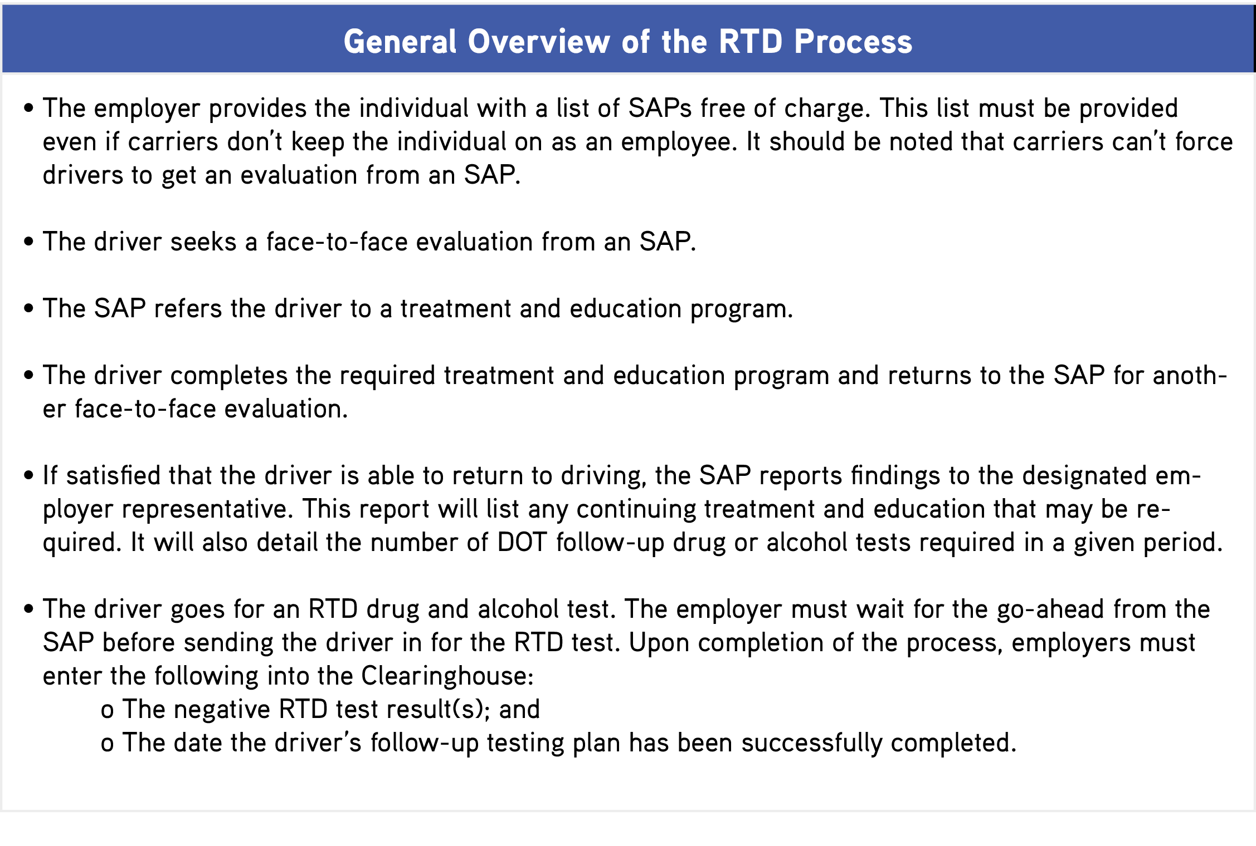

Violation data found within the Clearinghouse will be denoted by a driver’s CDL number and date of birth. Moreover, the Clearinghouse is designed to interface with the Commercial Driver’s License Information System (CDLIS). This makes the system more difficult to cheat and allows stakeholders to track a driver’s drug and alcohol violations even if the driver changes jobs or applies for a CDL in a different state.
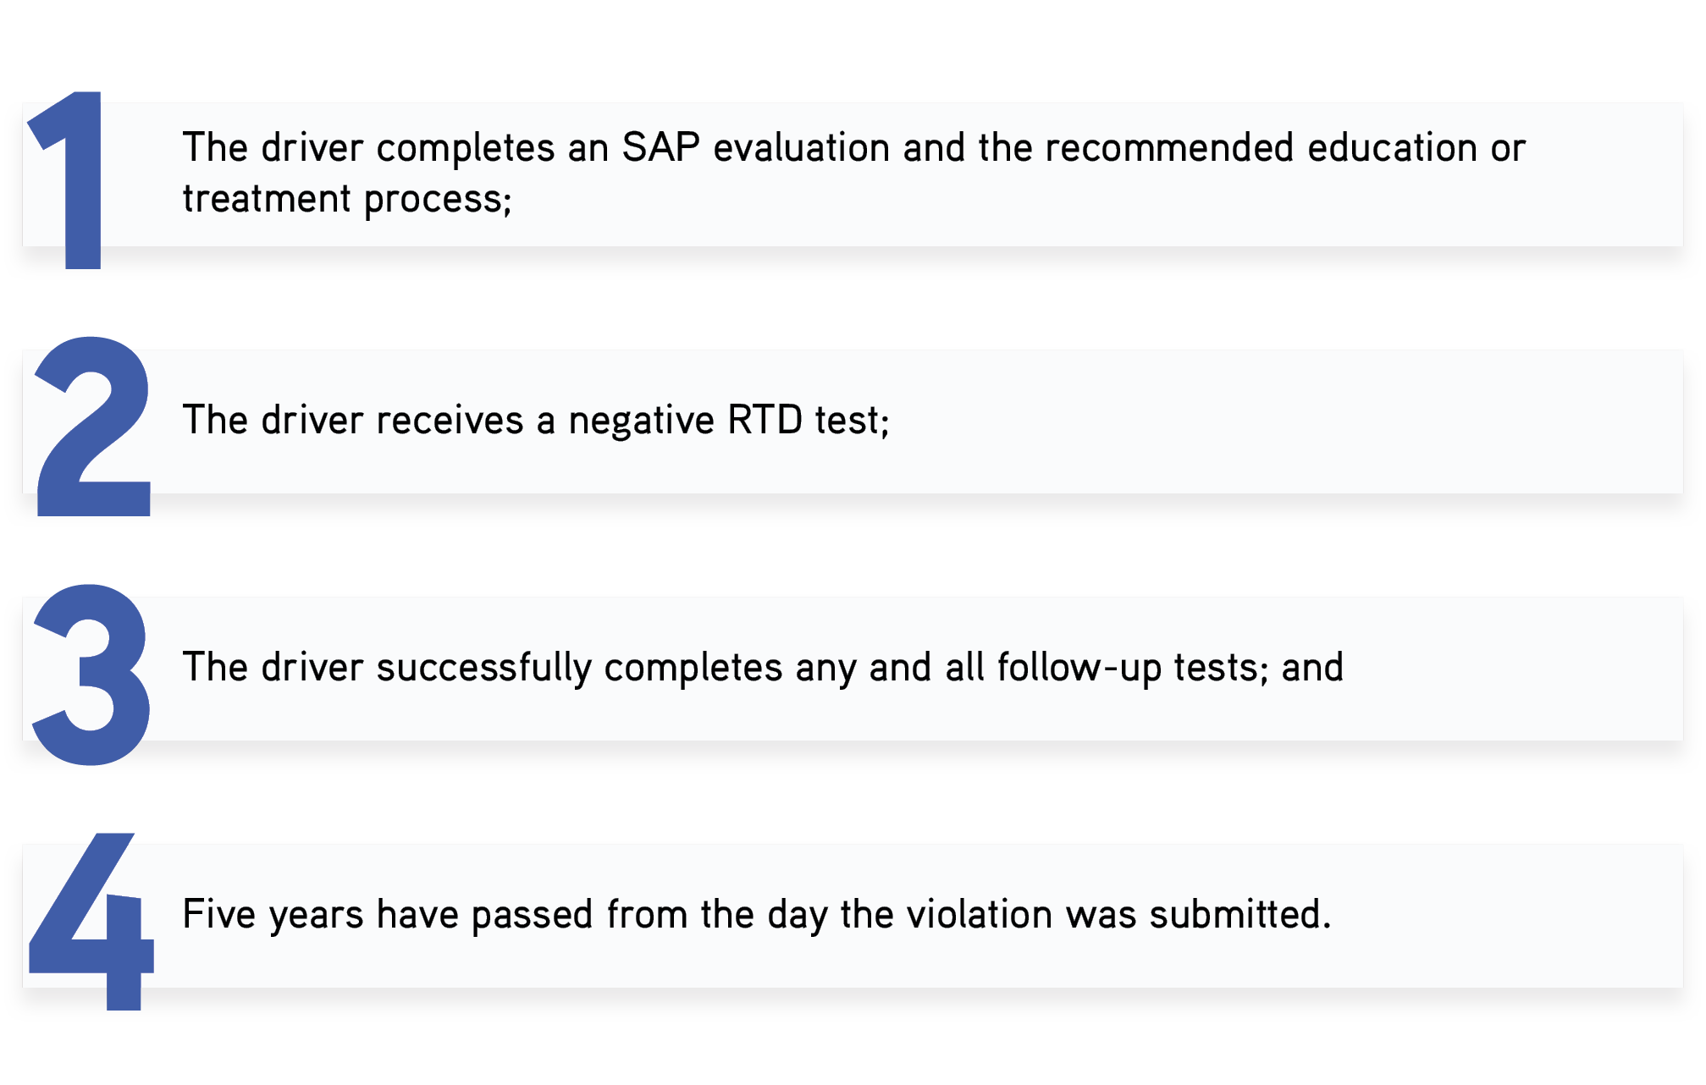
Records of violations remain in the Clearinghouse until:

How the Clearinghouse Will Be Used
Depending on the stakeholder, the Clearinghouse will be utilized in various ways, as summarized below:
- Employers—Employers will use the Clearinghouse to report drug and alcohol violations and to ensure that current and prospective employees are permitted to perform safety-sensitive functions. If a CDL holder has a drug and alcohol program violation, employers will need to confirm the driver has successfully completed the RTD process. From an employer perspective, the basic Clearinghouse process is as follows:
  - The employer makes an electronic request for information.
  - The driver is notified and their consent is requested.
  - The FMCSA receives electronic consent from the driver.
  - If records exist, they are released to the employer, who will then use the records to determine the driver’s fitness for duty.
- CDL holders—Using the Clearinghouse, drivers can review violation records to confirm their accuracy. In addition, drivers can use the Clearinghouse to provide consent to current or prospective employers to access details about any drug and alcohol program violations. Drivers can also use the Clearinghouse to select a SAP, as needed.
- Medical review officers—In general, medical review officers will use the Clearinghouse to report verified positive drug test results, along with any refusals to test.
- SAPs—SAPs will use the Clearinghouse to report information regarding the RTD process, including initial assessment details and a driver’s eligibility status.
- Consortium and other third-party administrators—These entities will access the Clearinghouse on behalf of an employer to report drug and alcohol program violations and perform driver queries as required.
- State driver licensing agencies—These entities will query the Clearinghouse when finalizing licensing transactions.
While the Clearinghouse will benefit stakeholders in different ways, its overarching goal is the same—improve roadway safety by identifying CMV drivers who have committed drug and alcohol violations that render them ineligible to operate a CMV. While the goal of the Clearinghouse and its basic functionality is relatively straightforward, there are a number of complex compliance steps employers need to consider.

Compliance Considerations: Employers
The Clearinghouse will offer employers a centralized location to query driver information and report drug and alcohol program violations incurred by current and prospective employees who hold CDLs or CLPs. These employers must use the Clearinghouse to:
- Conduct a full query—an electronic check-in to the Clearinghouse—as part of each pre-employment driver investigation process.
- Conduct limited queries at least annually for every driver they employ.
- Request electronic consent from each driver for a full query, including every pre-employment query.
- Report drug and alcohol program violations.
- Record negative RTD test results and the date of successful completion of a follow-up testing plan for any driver they employ with unresolved drug and alcohol program violations.
Any employer, employee or service agent that does not comply with its responsibilities under the new rule may be subject to civil or criminal penalties. Following an issue of noncompliance, employers, employees or service agents may receive a notice of claim or violation and have an opportunity to contest any charges. The type and severity of the penalty will likely depend on the circumstances surrounding the violation.
The following sections will examine the query process, reporting obligations and record-retention requirements in more detail.

Conducting a Query
A query is an electronic check in the Clearinghouse conducted by an employer or its designated consortium/third-party administrator. This type of query is used to determine whether current or prospective employees are prohibited from performing safety-sensitive functions, such as operating a CMV, due to unresolved drug and alcohol program violations.
Motor carriers must conduct a query of the Clearinghouse within a 365-day period based on a driver’s hire date (once a year). This requirement applies for every CDL holder employed. While employers must complete annual queries, they can also opt to conduct additional searches as often as they’d like, provided they obtain an employee’s consent and are willing to pay the fee.
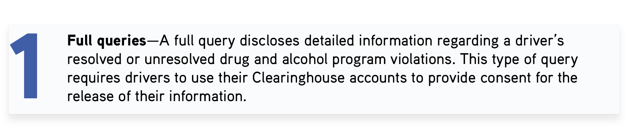
Per the FMCSA, annual queries can be full or limited, as further explained below:

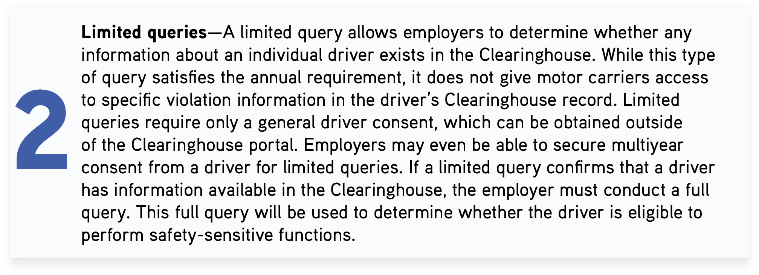

In addition to the annual queries, employers must conduct a full pre-employment query before hiring any driver for a safety-sensitive position.
The FMCSA will charge a flat fee of $1.25 for every full and limited query of the Clearinghouse. The FMCSA offers bundle plans, but motor carriers will not receive any discounts unless they purchase an unlimited bundle plan for $24,500. While the unlimited plan is only good for one year, other bundles do not expire. Please note that consortium/third-party administrators can’t purchase queries on an employer’s behalf.
In general, the query bundle motor carriers purchase will depend on the number of queries they will need to conduct. For more information on queries and pricing, click here.
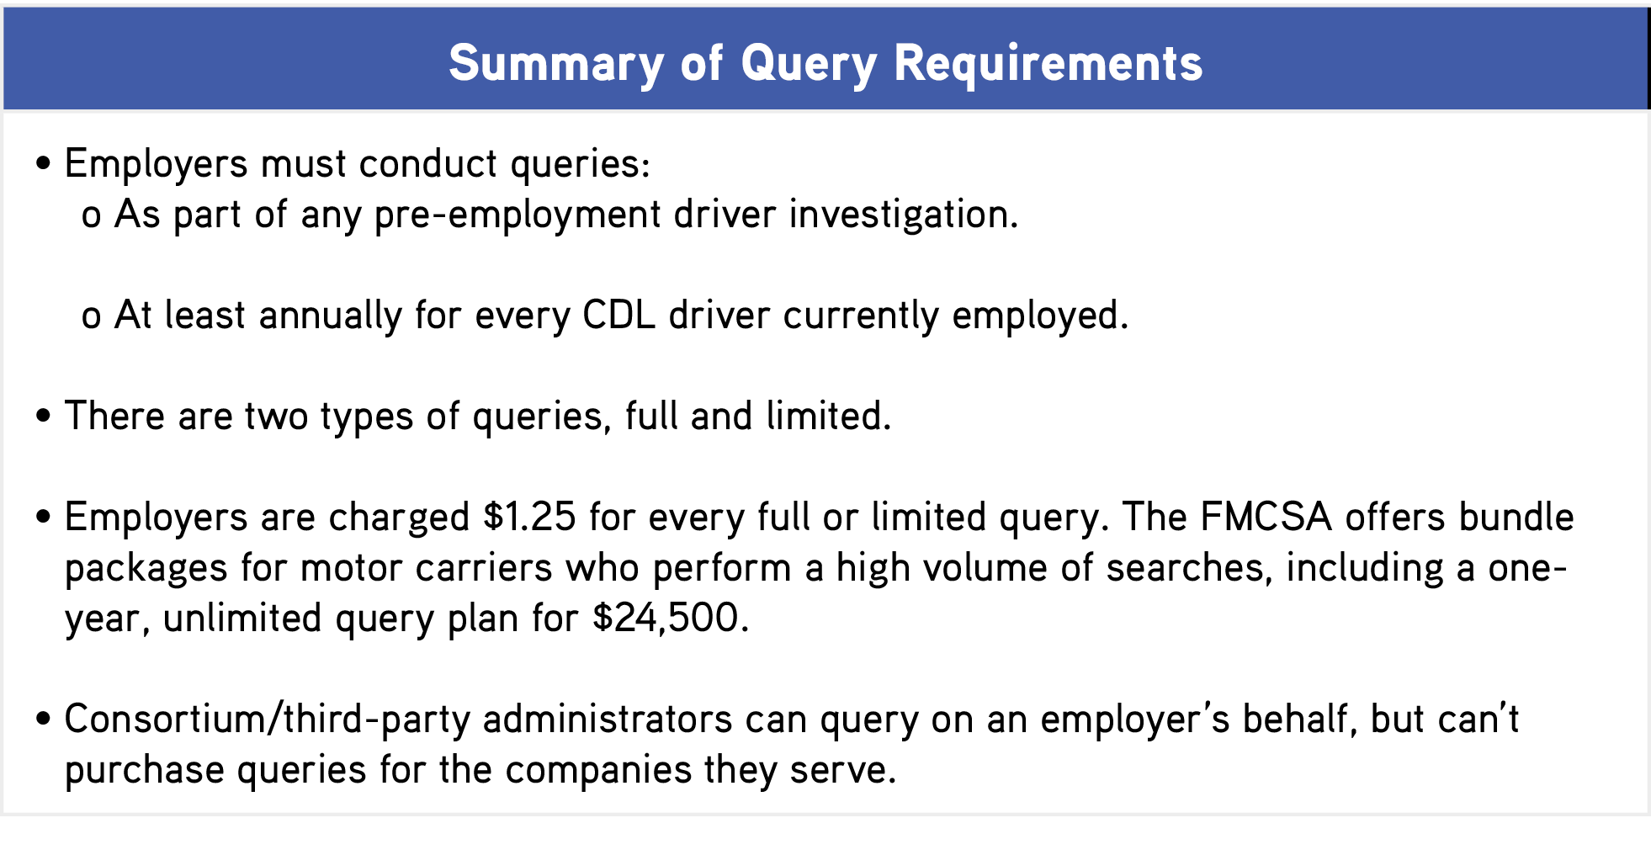

Reporting Requirements
Per the Clearinghouse rules, FMCSA-regulated employers, medical review officers, designated employee representatives, SAPs and consortium/third-party administrators are required to report key information about CDL and CLP holders to the Clearinghouse. The table below lists reportable violations and summarizes the types of information that employers and SAPs must report about them.
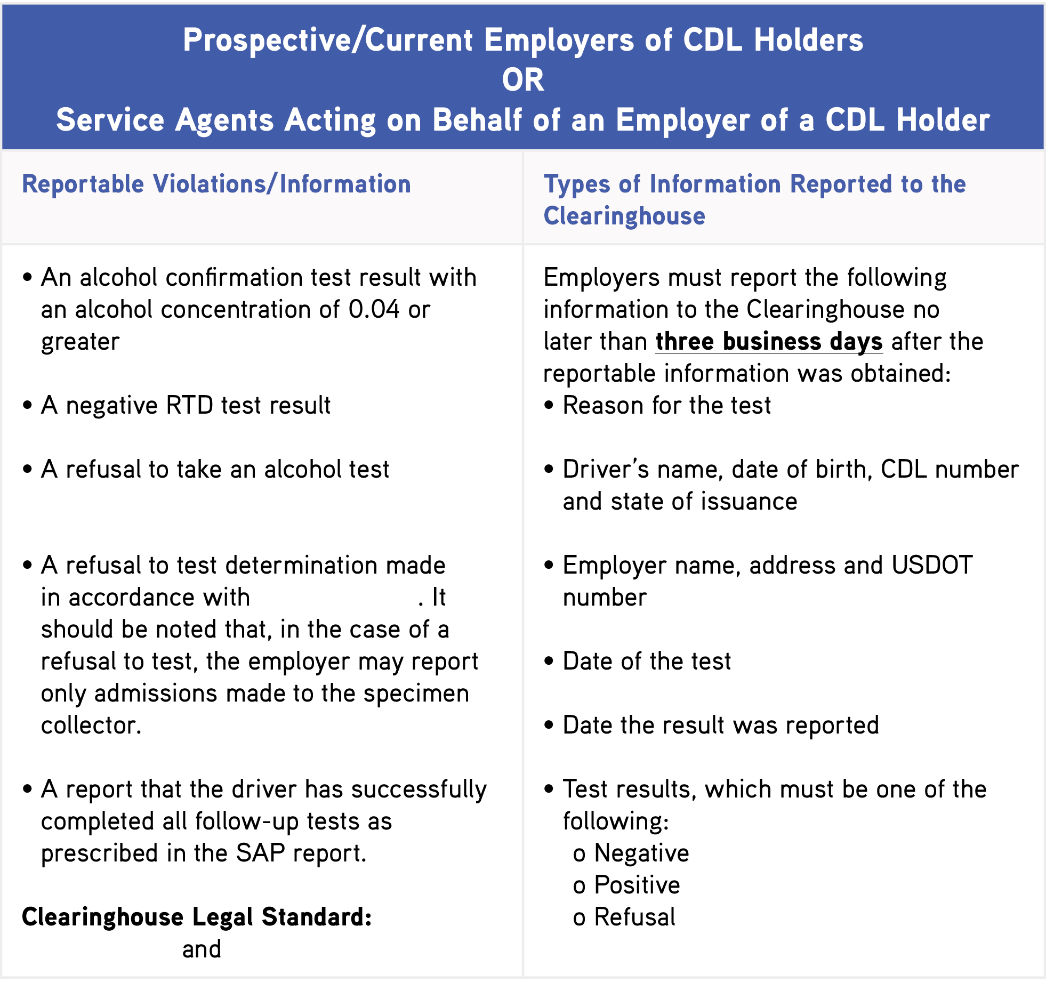
382.705(b)(1)
49 CFR 40.191
382.705(b)(2)
(49 CFR 40.261)

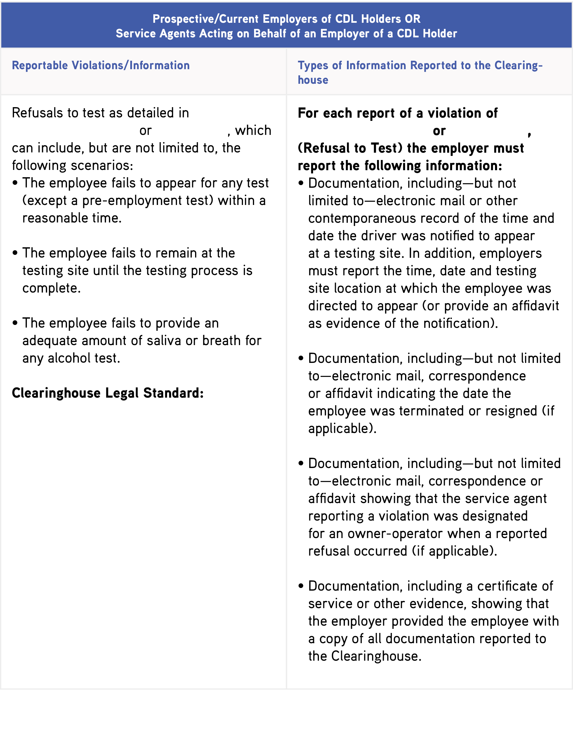

40.191(a)(1)
382.705(b)(3)
49 CFR 40.261(a)(1)
40.191(a)(1)
49 CFR 40.261(a)(1)

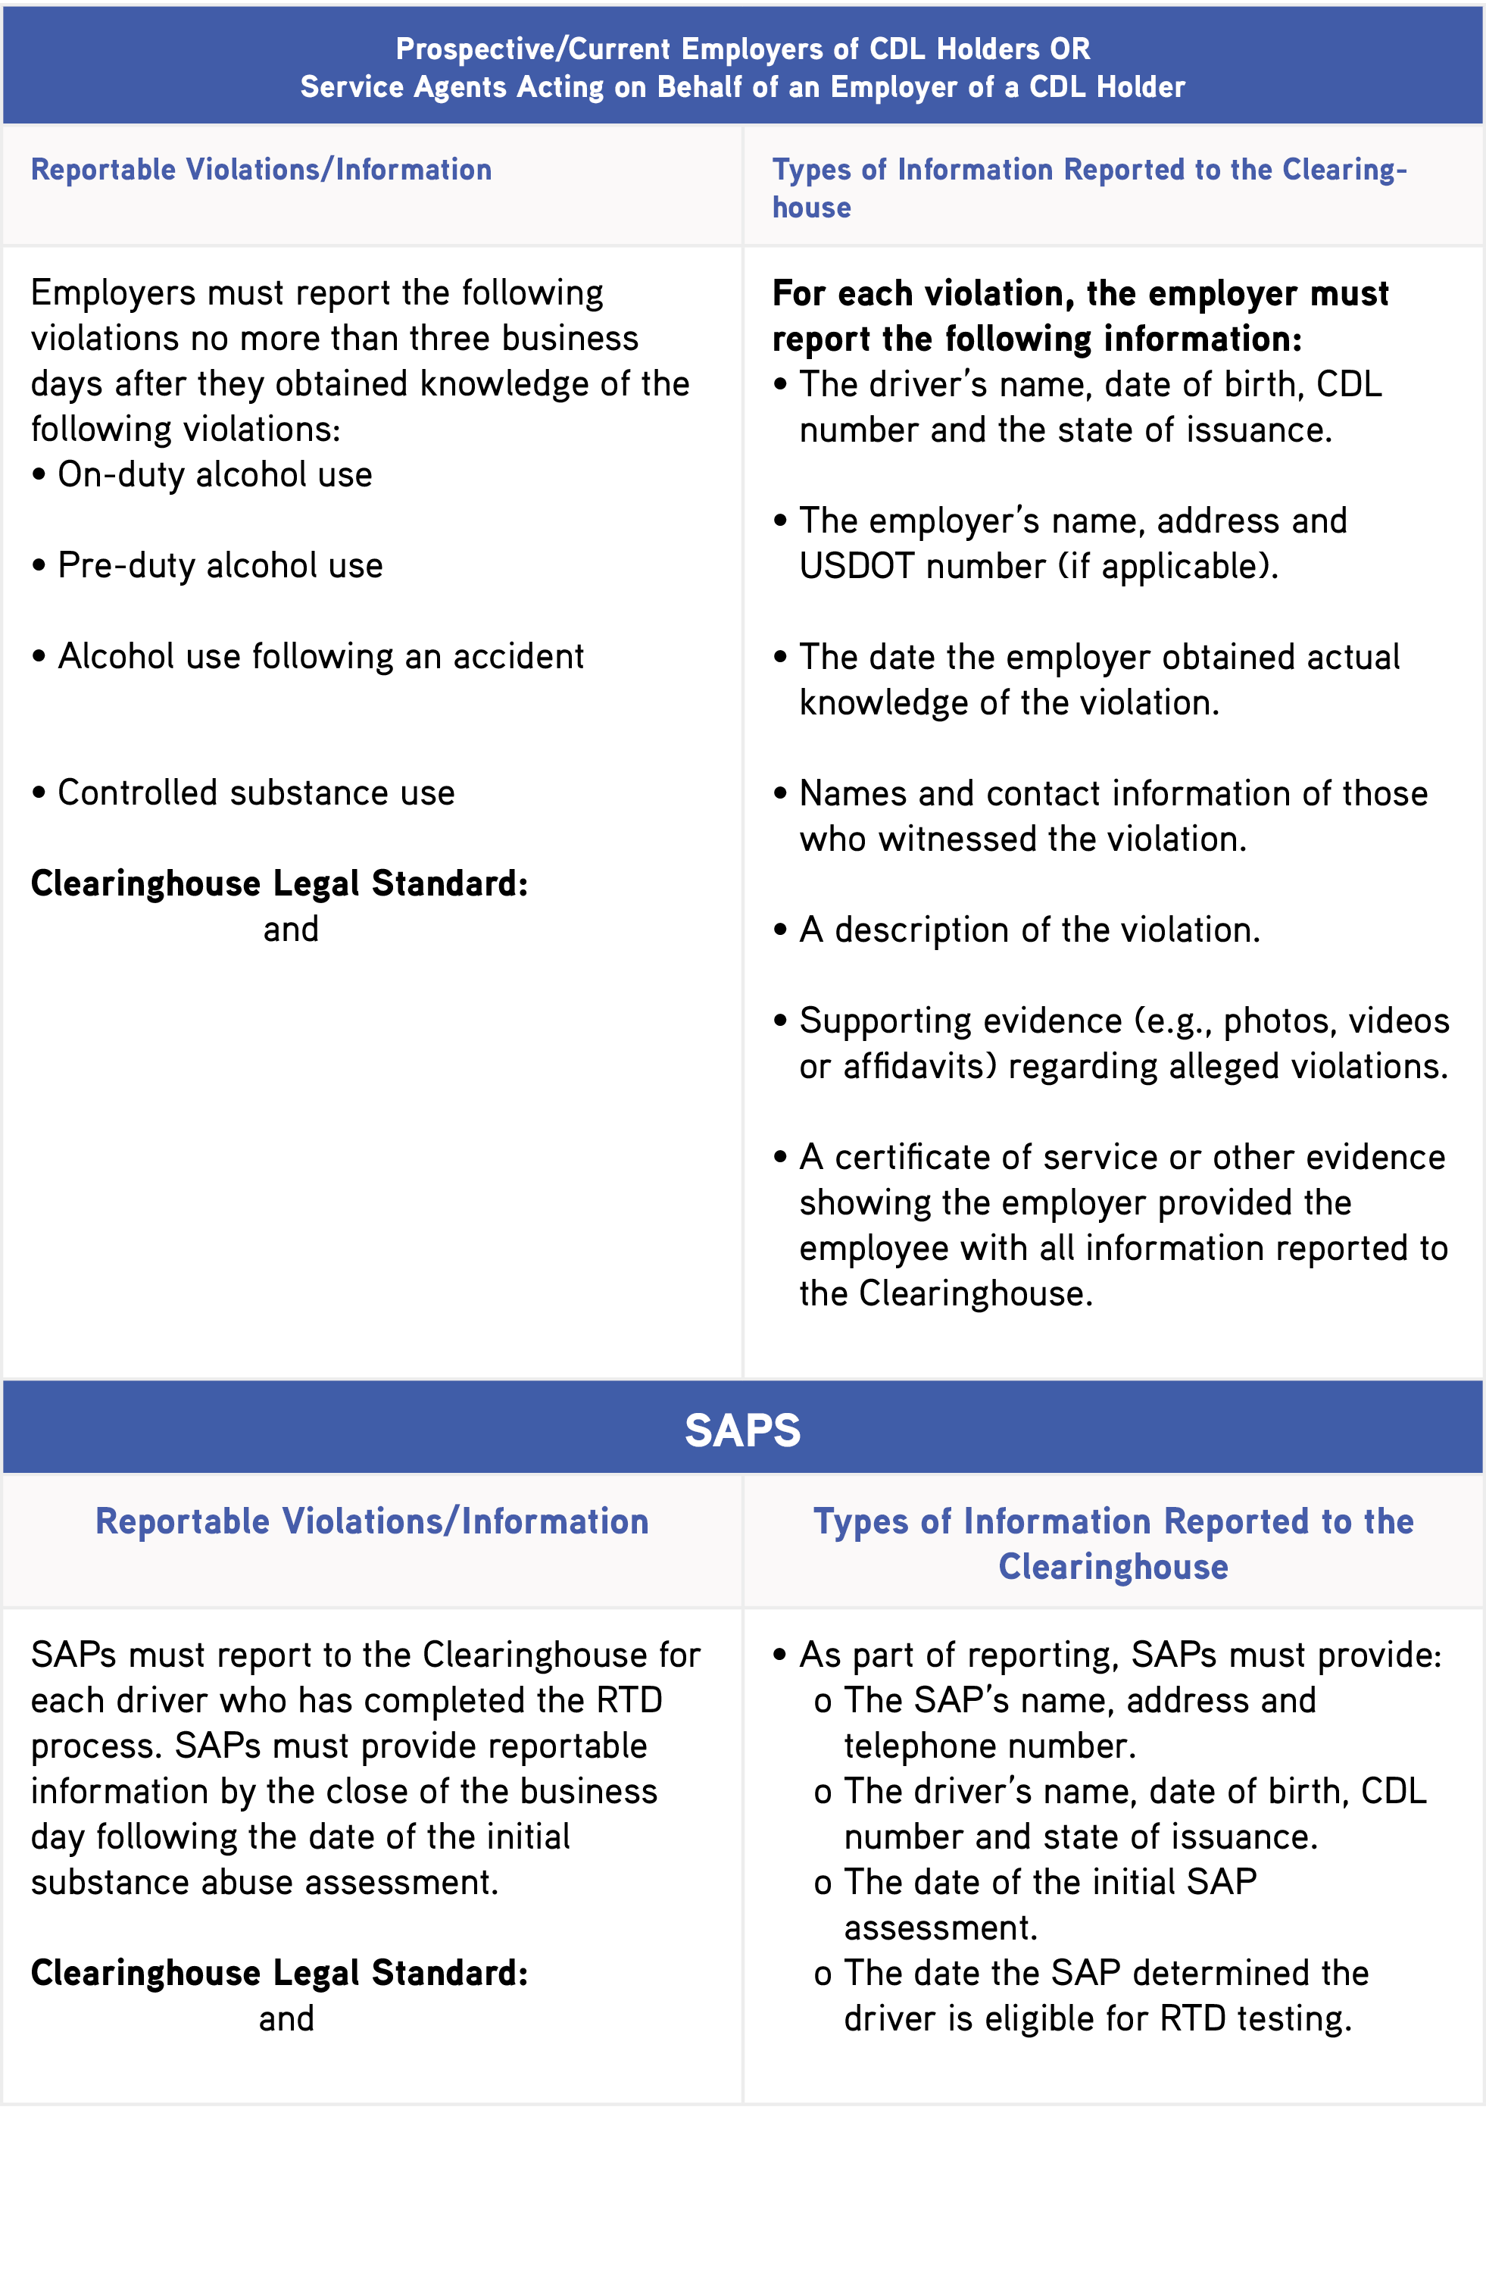

(382.209)
(382.213)
(382.205)
382.705(d)(1)
382.705(b)(5)
382.705(b)(4)
382.705(d)(2)

(382.207)

Penalties
When it comes to reporting, the FMCSA expects information provided to be truthful and accurate. An employer or service agent who knowingly submits false information to the Clearinghouse may be subject to criminal or civil penalties. Employers and consortium/third-party administrators are required to provide specific documentation to support the reporting of actual knowledge or a refusal to test. The FMCSA will remove information from a driver’s Clearinghouse record that is determined to be false.

Driver Notification and Consent
There are specific steps employers need to follow in order to avoid violating the privacy of their drivers. In fact, the Clearinghouse regulation explicitly states that motor carriers may not query the Clearinghouse without first obtaining a driver’s written or electronic consent.
The type of consent required depends on the type of query. For a limited query, general consent is required. This must be obtained outside the Clearinghouse. Employers may obtain a multiyear general consent from the driver for limited queries. For a full query, the driver must provide specific, prior consent to the employer. This consent must be provided electronically within the Clearinghouse.
The employer conducting the search must retain the consent for three years from the date of the last query.
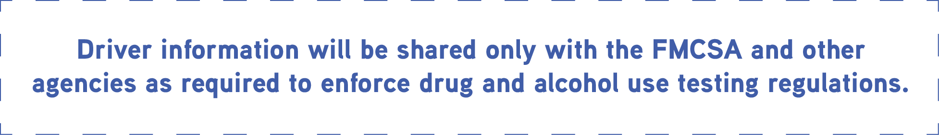

Driver information will not be available to the public. Only authorized users will be able to register and access the Clearinghouse for designated purposes. The Clearinghouse will require authentication (a username and password) to access records, and the FMCSA must notify a driver when information concerning that driver has been added to, revised or removed from the Clearinghouse.
When information concerning a driver has been released from the Clearinghouse to an employer, the employer must specify the reason for the release in a notice that also informs the driver how to access his or her information in the Clearinghouse.

Updating Programs and Policies on the Misuse of Alcohol and Controlled Substances
The FMCSA’s regulations require employers to provide their drivers with educational materials about the FMCSA's drug and alcohol testing program requirements as well as about workplace policies for implementing those requirements. The new rule also requires employers to include notice in the educational materials that violations of FMCSA's drug and alcohol testing program would be reported to the Clearinghouse.
One of the simplest ways to educate your drivers about the Clearinghouse and reduce the risk of impaired driving in your fleet is through controlled substance and alcohol testing programs and policies.

Controlled Substance and Alcohol Testing Programs
As an employer, you have a responsibility to implement drug and alcohol testing programs. The primary goal of these programs is to ensure your fleet does not allow a driver to operate a commercial motor vehicle if:
- The driver receives a positive, adulterated or substituted drug test result.
- The driver receives an alcohol confirmation test result of 0.04 or higher.
- The driver refuses to submit to a test for drugs or alcohol.
- The driver drank alcohol while performing safety-sensitive functions or within four hours of performing safety-sensitive functions.
- The driver used a controlled substance.
At a minimum, these programs should identify where and when employees will be tested. Again, the FMCSA has very specific requirements as to when drug and alcohol tests must occur. As such, employers must have an understanding of these requirements and ensure drivers are being tested appropriately at certified testing facilities. The chart below lists the testing types and includes details of when each type of test should be administered:
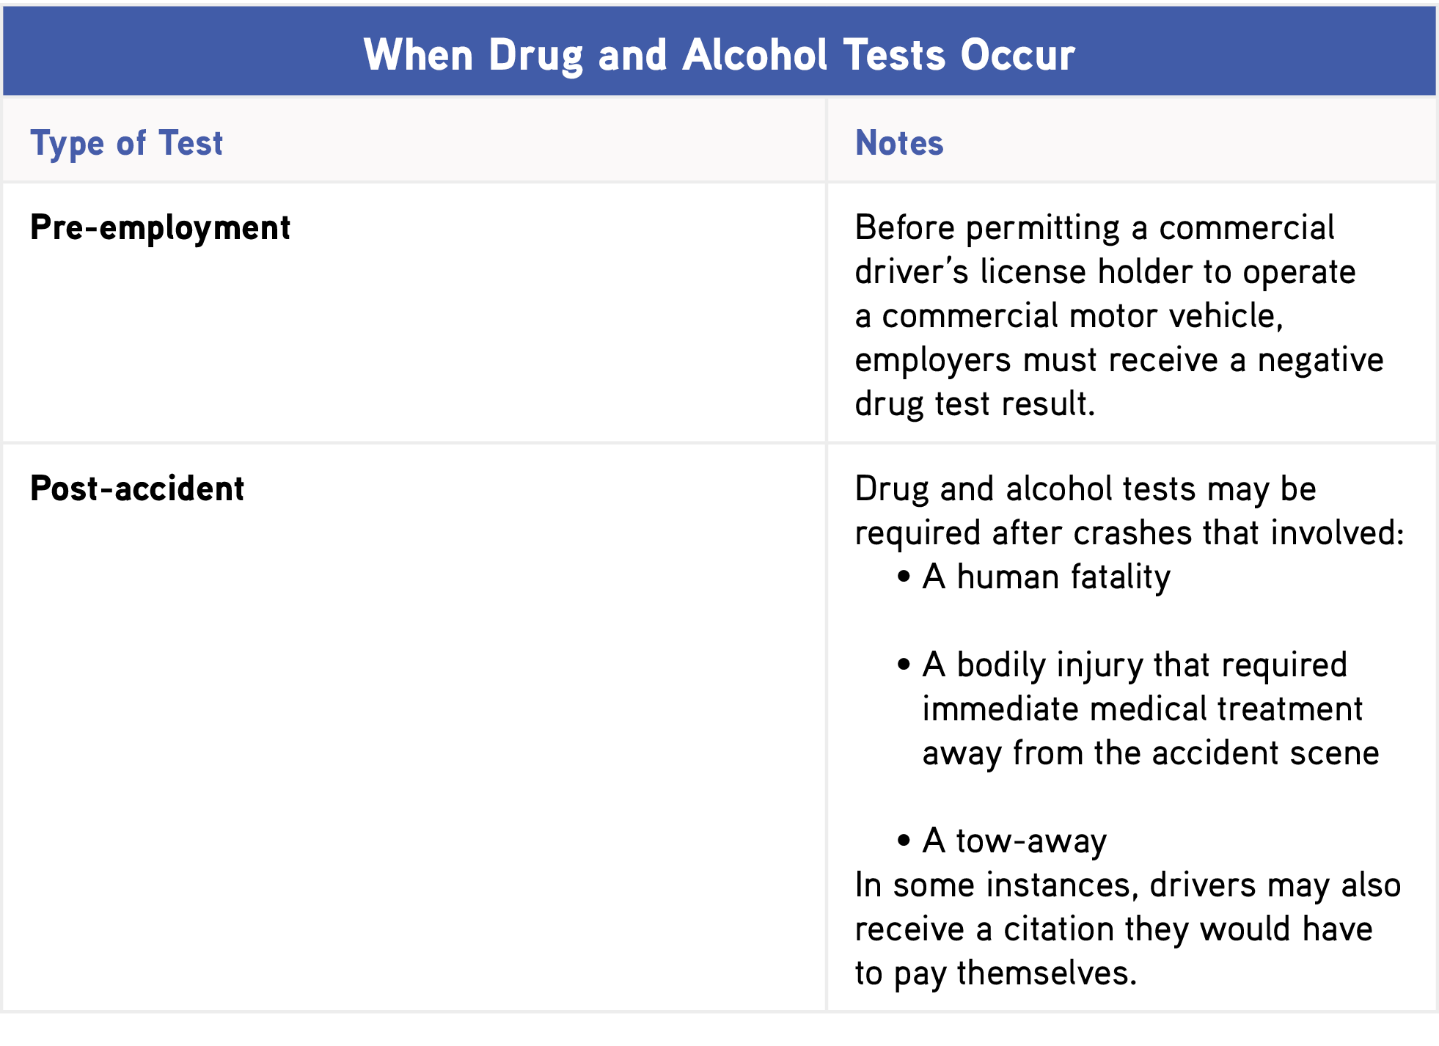

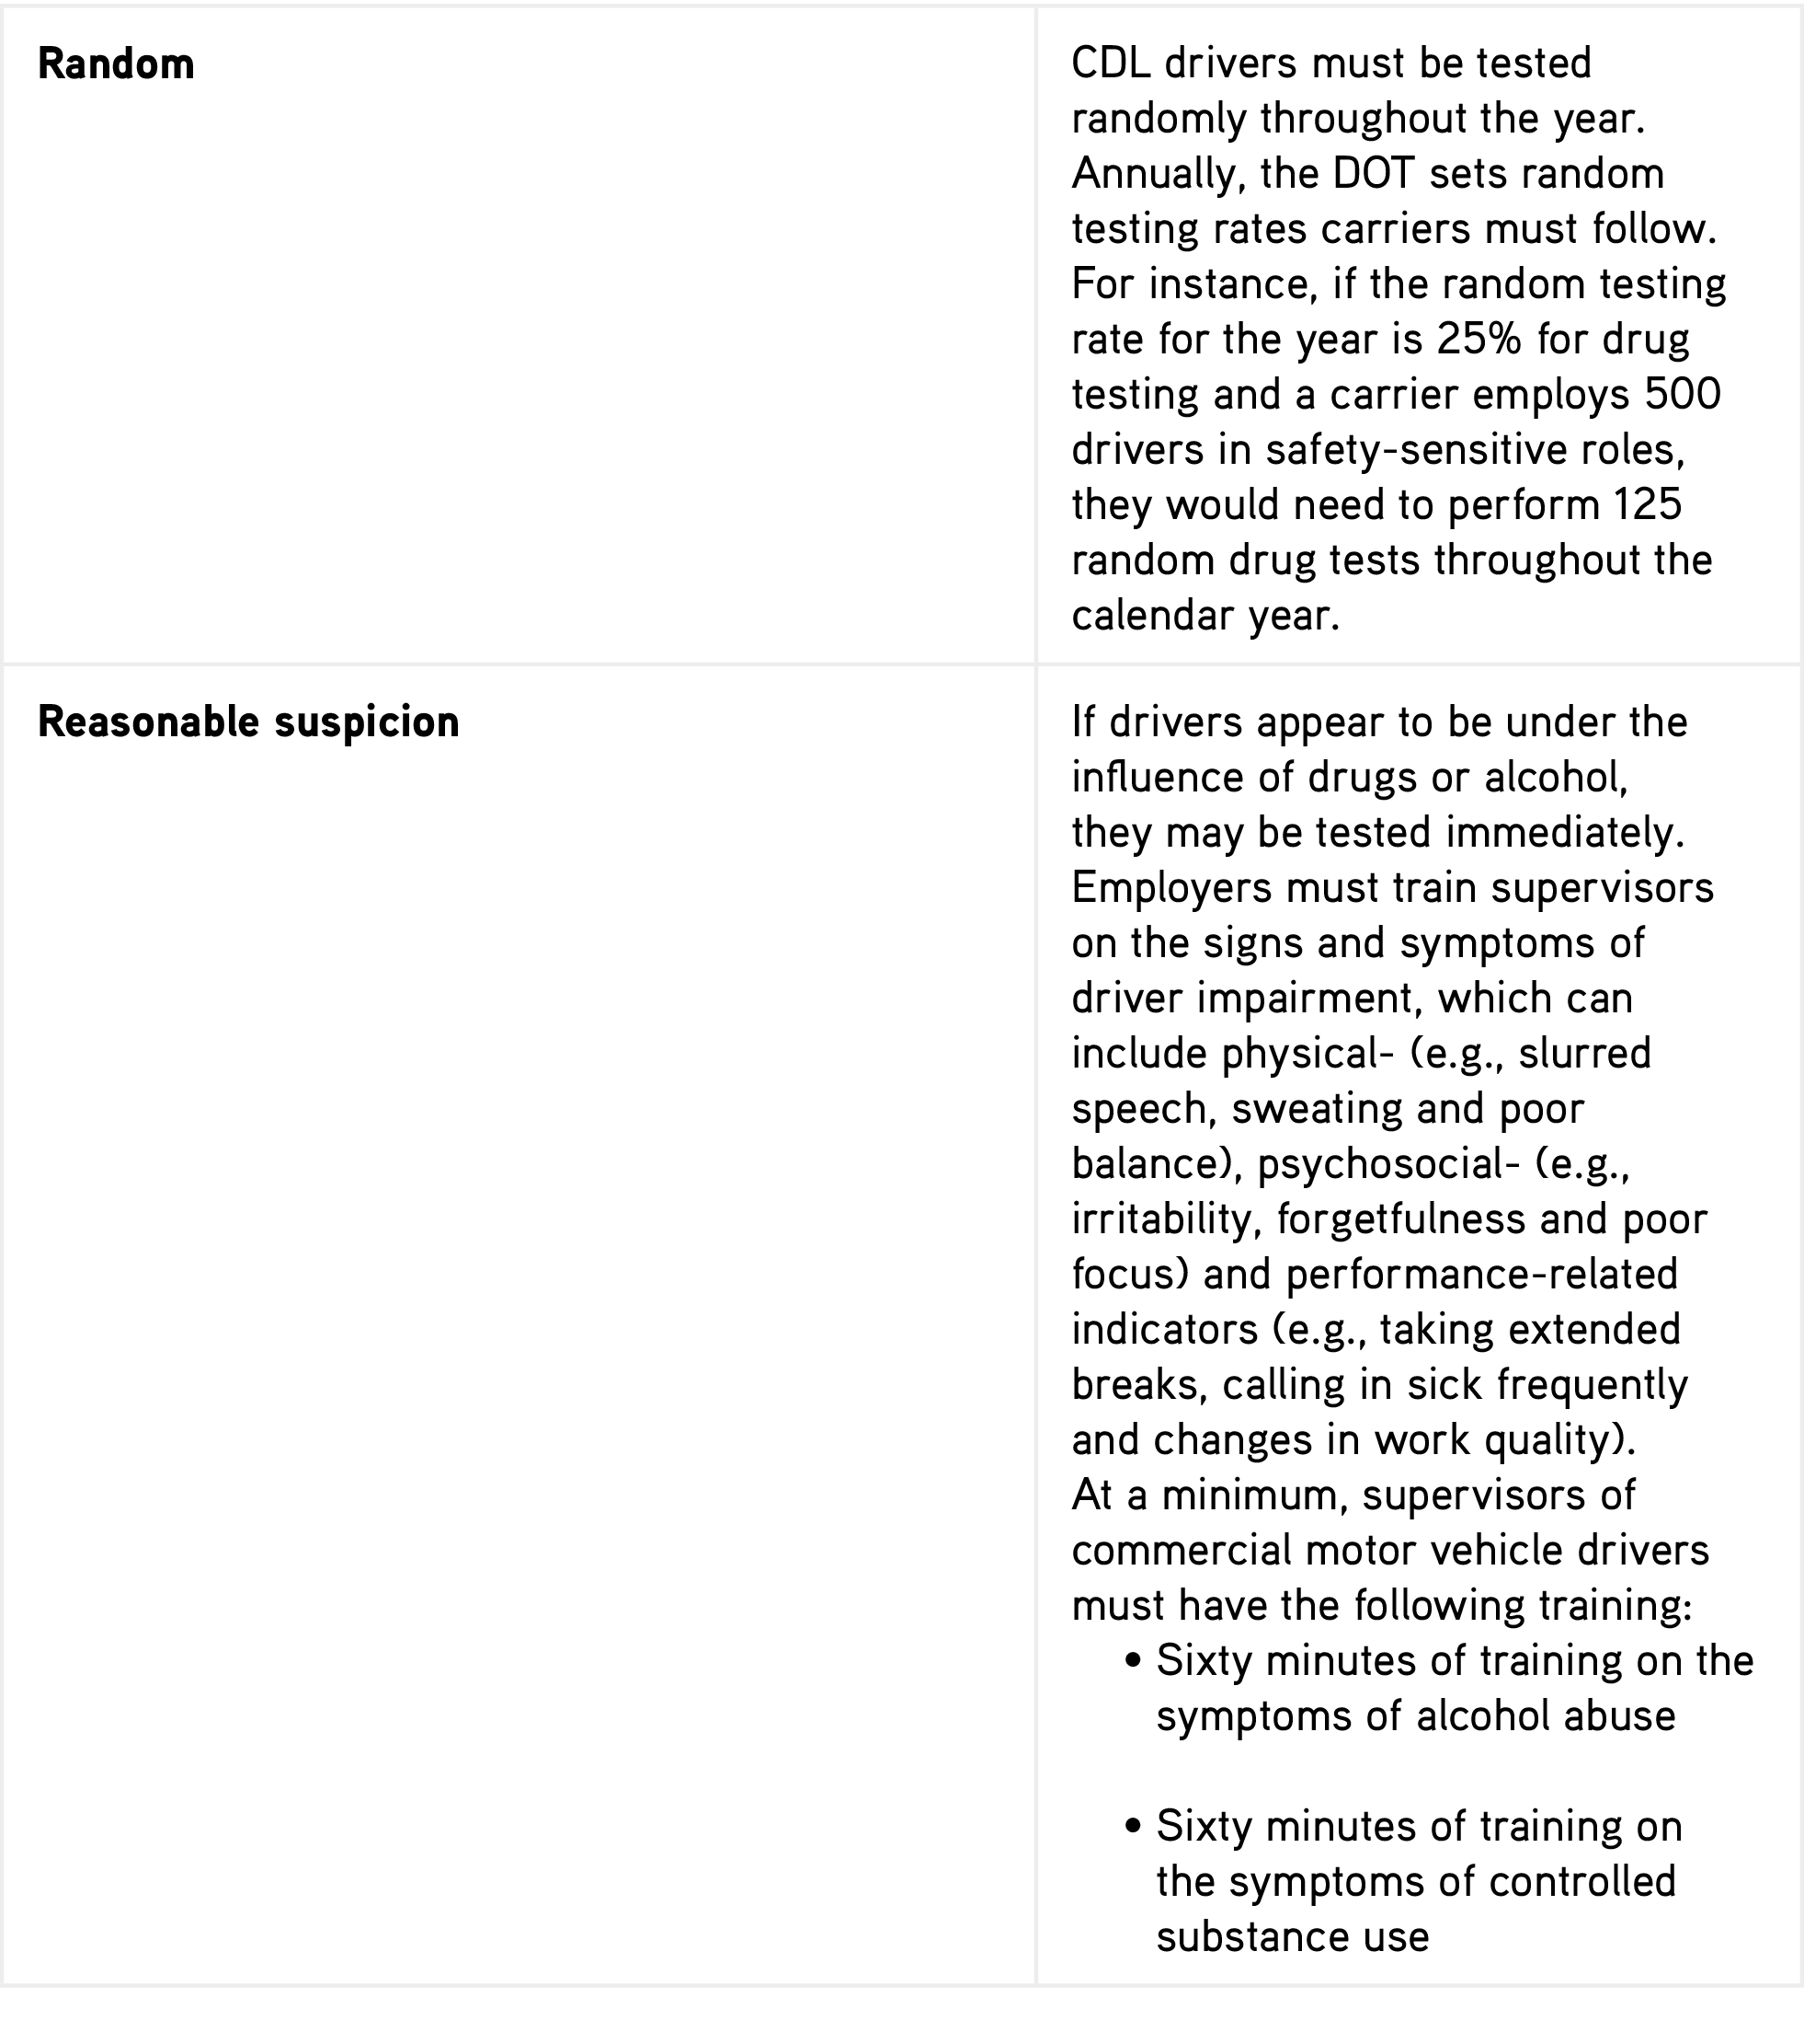

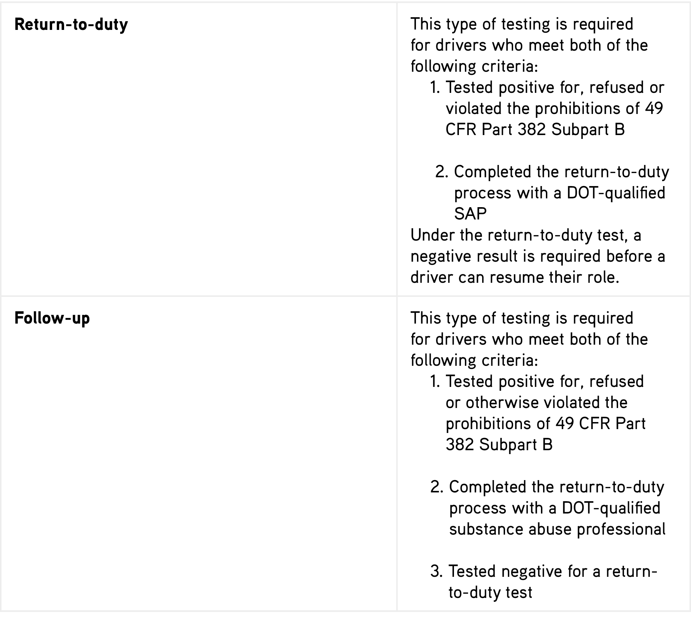

Written Policies Related to Controlled Substance and Alcohol Misuse
The FMCSA requires carriers to develop a written policy on controlled substance use and alcohol misuse in the workplace as part of their drug and alcohol programs. Carriers must also communicate the contents of this policy to their drivers.
At minimum, a carrier’s written policy should contain:
- A statement outlining the policy’s objectives
- Information regarding the effects of alcohol and controlled substances
- An overview of which drivers are subject to testing
- An explicit statement that employee participation is required
- Details regarding when employees must adhere to policy requirements (e.g., while on duty, four hours prior to work or while performing safety-sensitive functions)
- A list of prohibited behaviors and behaviors that constitute a refusal to submit to a test
- A summary of when testing may occur
- Details regarding testing procedures
- The consequences of failing a test
- The name of an individual who can answer questions related to the policy
The FMCSA also requires carriers to secure a signed statement from each employee confirming that the employee has received the policy and understands what’s expected of him or her.
As you develop your policy, consider involving other key members of your organization, like union representatives, medical review officers, SAPs, breath alcohol technicians and screening test technicians. It’s also important to review your policy alongside legal representatives, who can help you ensure there are no conflicts between the provisions of your policy and FMCSA, federal, state or local regulations.

Compliance Considerations: Drivers
Once a driver has registered for the Clearinghouse, he or she will be able to electronically access his or her own driver records at no cost. Records will include any violation information available in the Clearinghouse, along with the status of the driver’s RTD process, if applicable.
In addition, drivers can use the Clearinghouse to:
- Provide consent to release detailed violation information to a current or prospective employer; and
- Identify a SAP so that the SAP may enter specific information regarding the driver’s RTD activities.
The following sections will examine Clearinghouse compliance considerations from a driver’s perspective.

Types of Drivers Affected by the Clearinghouse
The Clearinghouse rule affects all CDL drivers who operate CMVs on public roads, which include, but are not limited to:
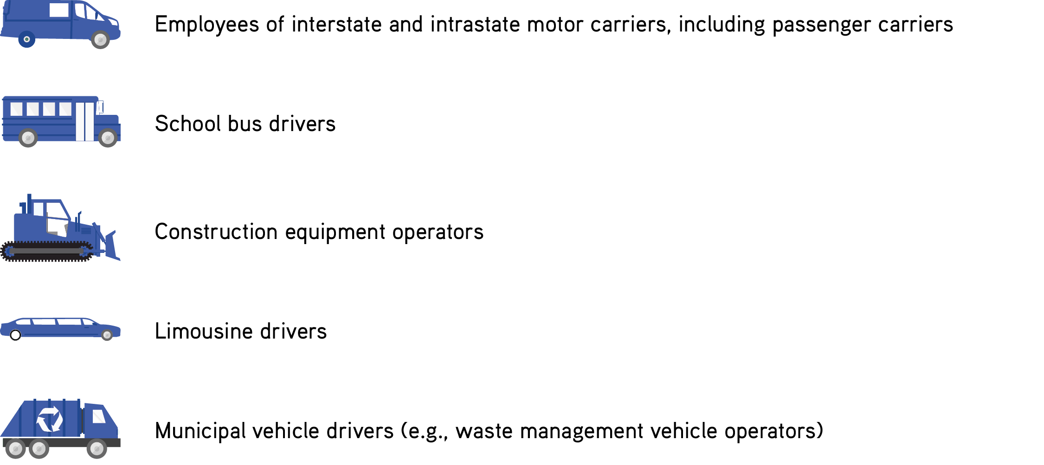

In addition, owner-operators are subject to Clearinghouse regulations from both an employer and employee standpoint. To help fulfill their obligations, owner-operators must designate a consortium/third-party administrator as part of the registration process. These administrators will run queries and report violations on the owner-operator’s behalf.
Drivers who have questions regarding the Clearinghouse and the role they play should be encouraged to speak with their supervisors.

Data Privacy and Providing Consent
The Clearinghouse will meet all relevant federal security standards, and the FMCSA will verify the effectiveness of data protections on a regular basis. Again, driver information will not be available to the public.
The FMCSA will only share detailed drug and alcohol violation information with prospective or current employers when a driver has provided explicit consent. What’s more, driver information will only be shared with the FMCSA and other enforcement agencies as required.
There are effectively two types of consent—one for limited queries, and another for full queries. The table below outlines the distinctions between these two types of consent.
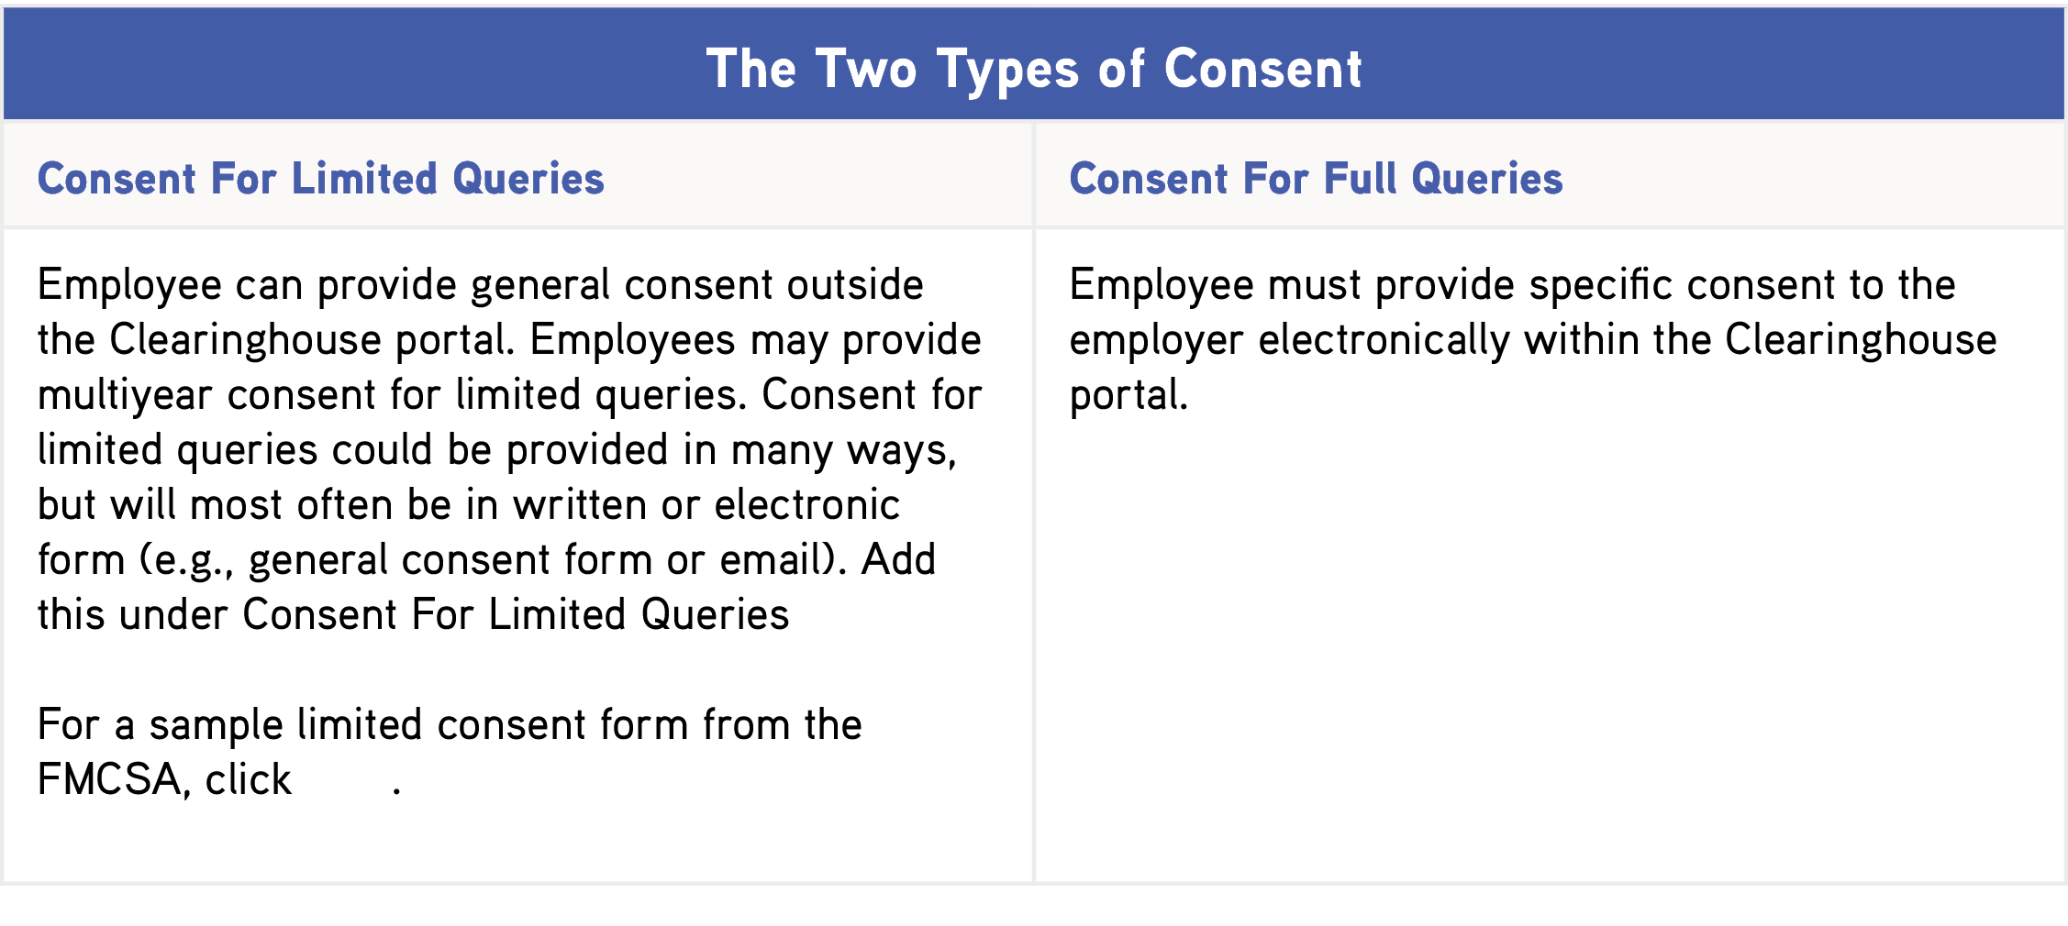

here

If a driver refuses to provide consent, they will not be allowed to perform safety-sensitive functions. Drivers will have the right to request that inaccurate information in the Clearinghouse be corrected or removed. However, drivers may only challenge the accuracy of information reported, not the accuracy or validity of test results or refusals to test.
It should be noted that drivers will only be able to access their own information, not information regarding other drivers.

Continued Safety
As an employer, it’s your job to protect your drivers whenever they’re on duty. Utilizing the Clearinghouse will not only ensure FMCSA compliance, but it will help prevent impaired driving in your fleet and improve highway safety for everyone on the road.
However, there’s more to driver safety than drug and alcohol program compliance. To safeguard the well-being of your employees and to proactively address all of your exposures, contact HNI today. We can provide a number of risk management resources to help you account for common motor carrier pain points, allowing you to focus on growing your business.

Clearinghouse FAQs
Use this list of frequently asked questions to help your fleet meet CDL Drug and Alcohol Clearinghouse requirements.
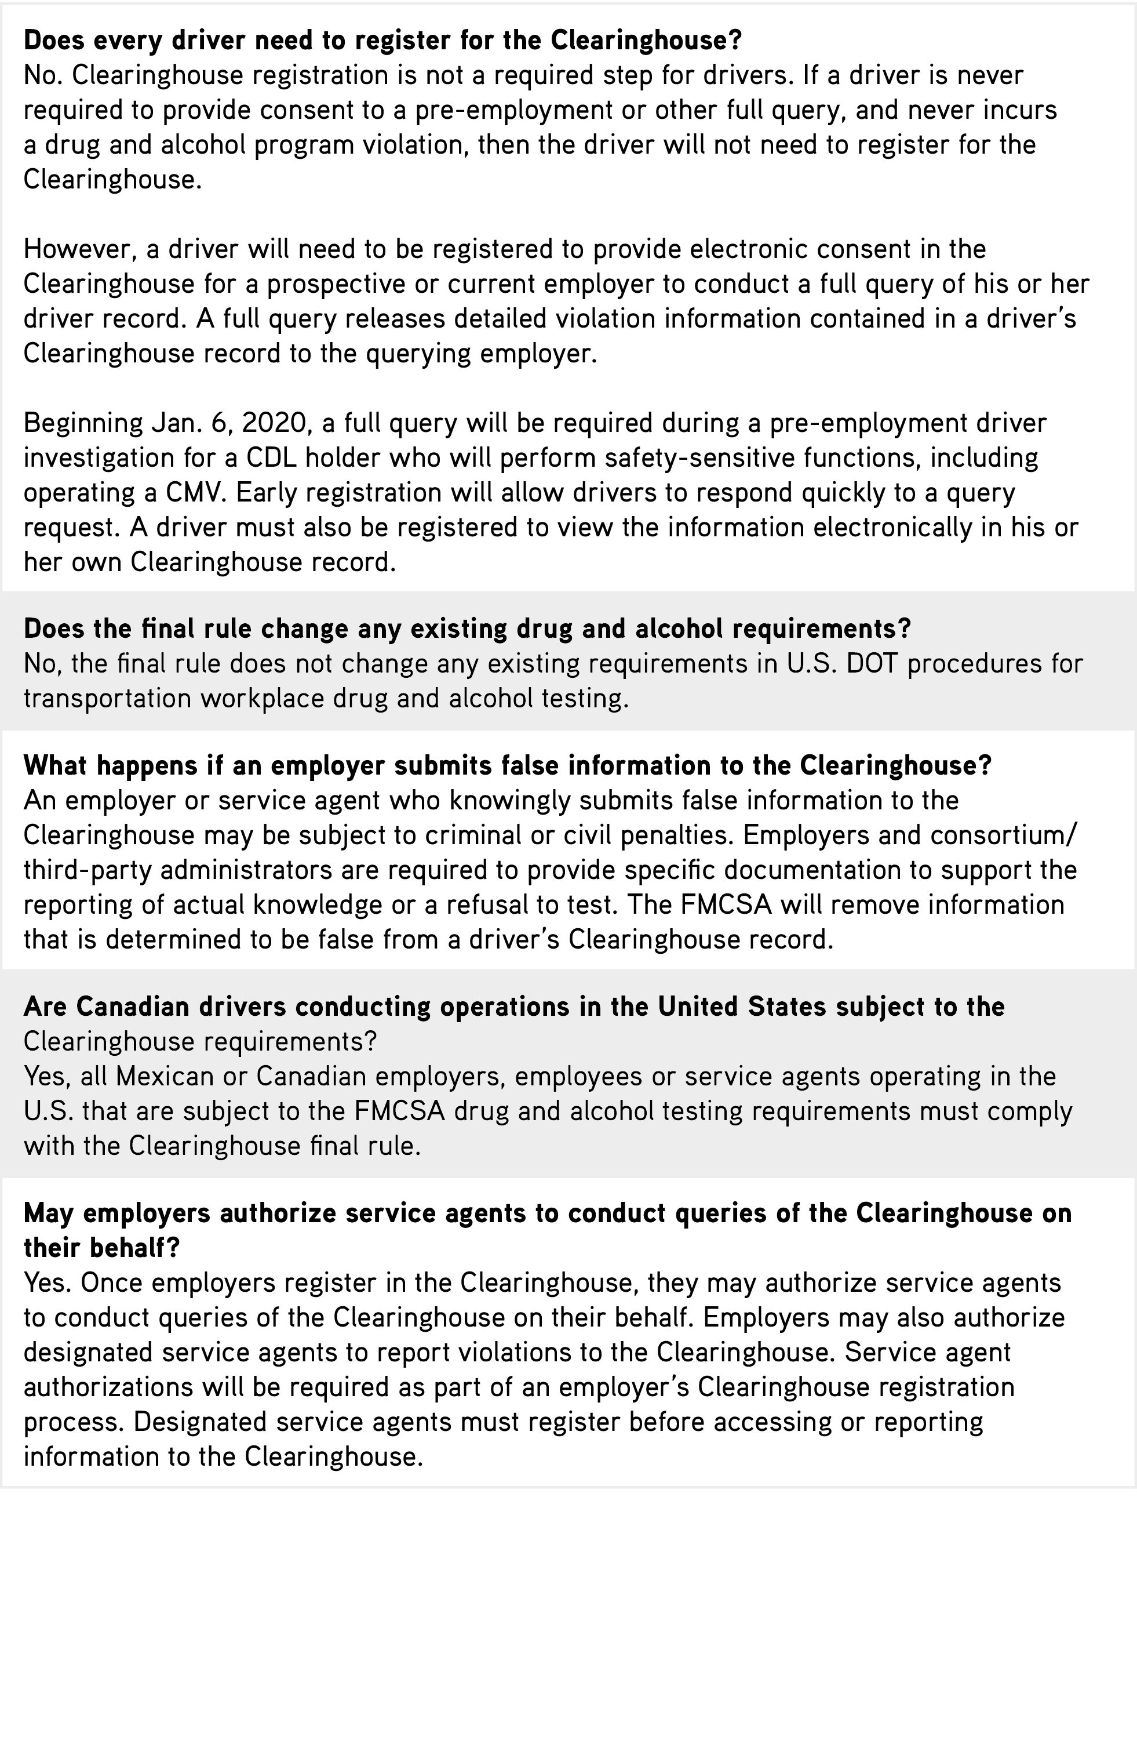

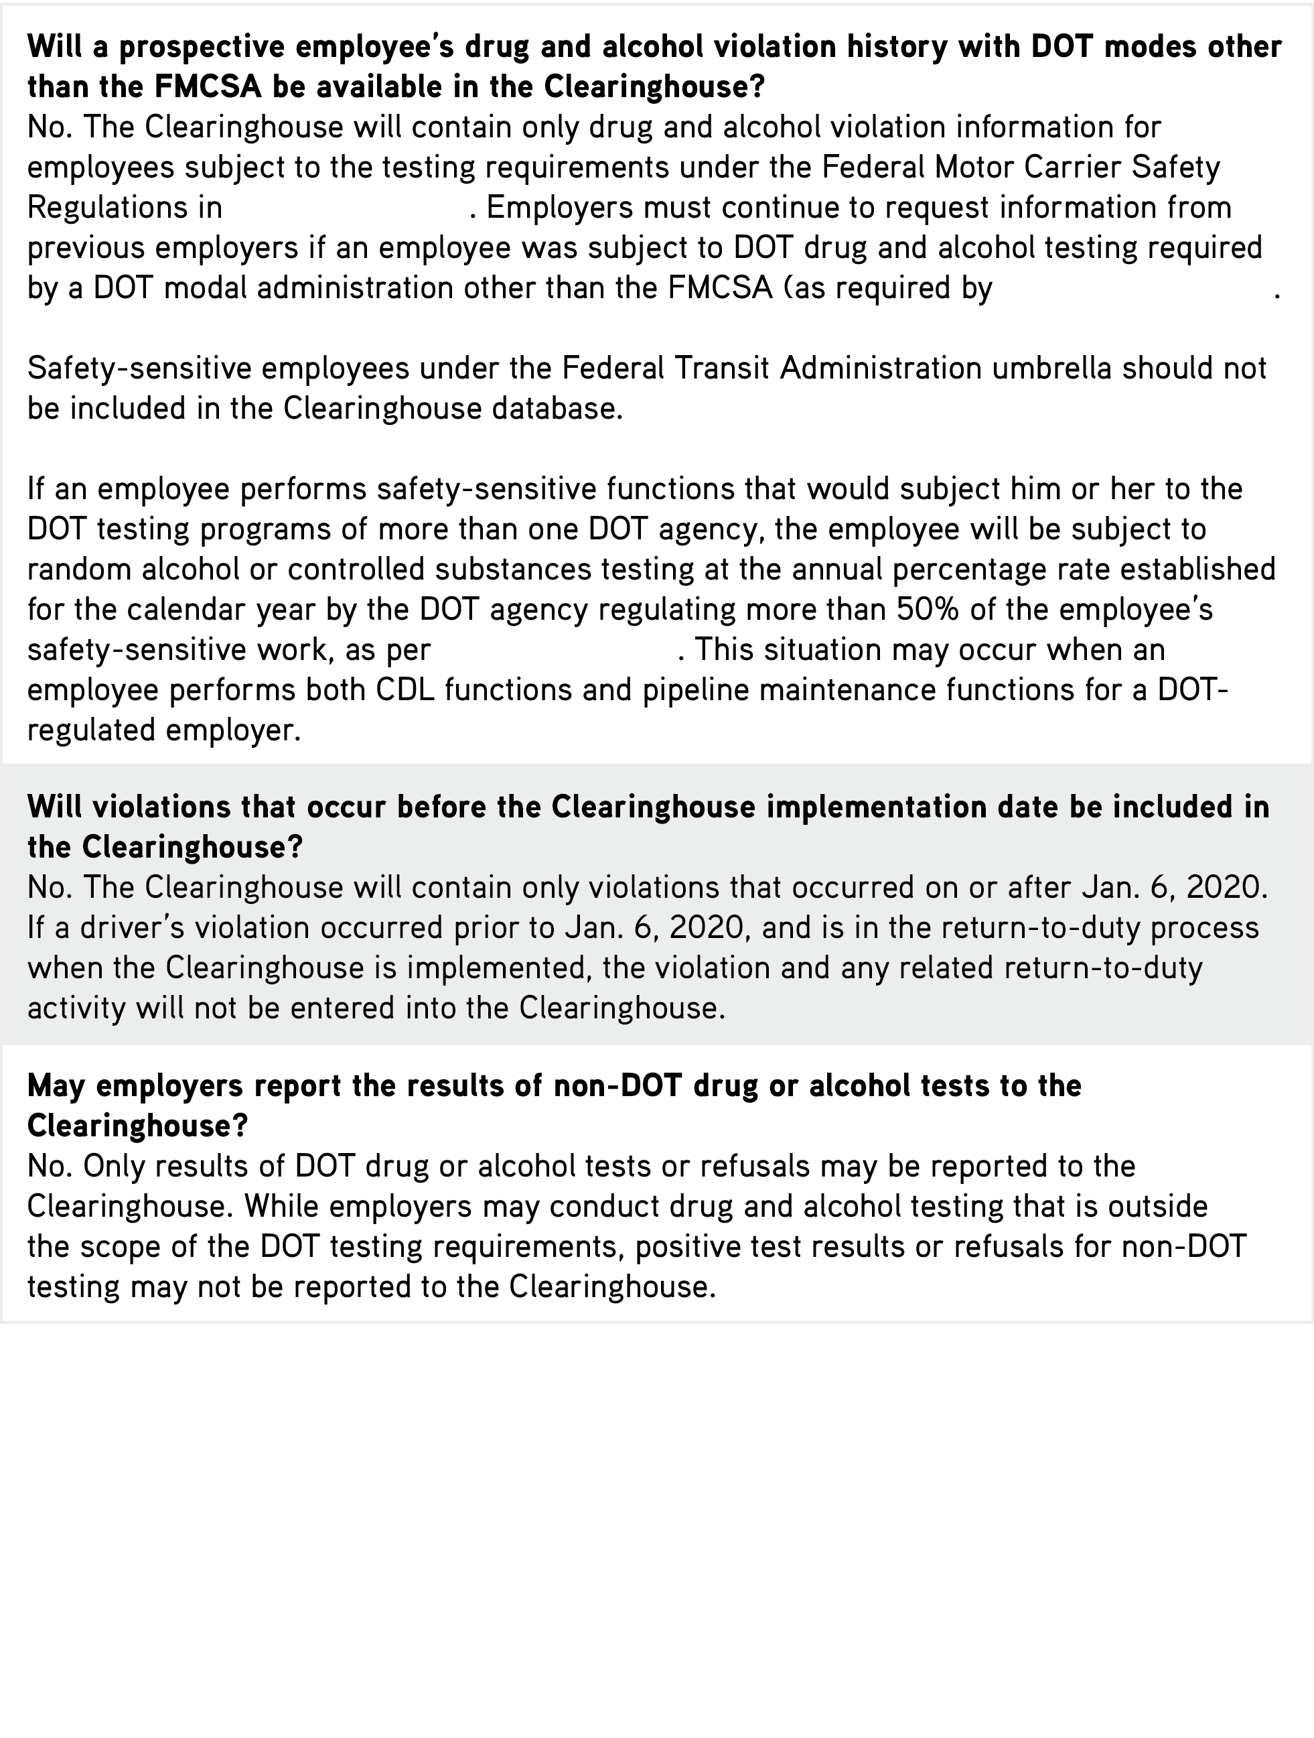

49 CFR Part 382

§ 391.23(e)(4)(i)(B)))

§ 382.305 (n)(0)

